USER REQUIREMENTS

The Bidder should provide the following in the specified order in Section 4 of the proposal/bid document.

Provide detail information of the proposed solution as per document enclosed. Please note that marking should be carried out in the following manner; The Remarks column should be used to explain or provide detail information.

DESCRIPTION | REMARKS
Rating - 5 | If the User requirement is met 100% as defined in the RFP without any work around method.
Rating - 4 | If the User requirement is met 75% as defined in the RFP without any work around method. Define the number of hours required for the modification and cost in US$ in the Remarks column, in order to provide 100% functionality as defined.
Rating - 3 | If the User requirement is met 50% as defined in the RFP without any work around method. Define the number of hours required for the modification and cost in US$ in the Remarks column, in order to provide 100% functionality as defined.
Rating - 2 | If the User requirement is met 25% as defined in the RFP without any work around method. Define the number of hours required for the modification and cost in US$ in the Remarks column, in order to provide 100% functionality as defined.
Rating - 1 | If the User requirement is met as a Work around method defined in the RFP. Define the number of hours required for the modification and cost in US$ in the Remarks column, in order to provide 100% functionality as defined.
Rating - 0 | If the User requirement is not met as a defined in the RFP and modifications are required. Define the number of hours required for the modification and costs in US$ in the Remarks column.

The NBL rating is as follows:
1 = critical; 2 = essential; 3 = nice to have

TRADE FINANCE
Ref | User Requirements | NBL Priority | Bidder’s Rating | Bidder’s Remarks
 | Functional requirements of Import Letters Of Credit, Amendments, Cancellations etc
 | Support for Opening and Amending a range of credits and bills including a Multi Branch operations. | 1 | 5 | Supported by T24.
 | Able to establish Imports Letters of Credit of different type:  Confirmed/Unconfirmed  Sight  Usance-Acceptance/Deferred Payments  Mixed Payments  Stand by LCs | 1 | 5 | Supported by T24 Trade Finance module.
 | Able to update immediately customer's credit utilization upon LC application approval. | 1 | 5 | Supported by T24.
 | The Reference No should have an indication as to the branch originating the transaction should be in sequential order. Next number should be easily determined & reserved. This would enable to provide a L/C number even if the system is out. | 1 | 5 | Supported by T24.  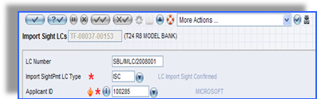  <= Deal Reference  <= Bank Defined LC No  Figure 1. Deal Reference for LC
 | Ability to interface with SWIFT /e.mail and other electronic data interchanges | 1 | 5 | T24 provides a standard interface to SWIFT and Telex. Integration with Mail, Fax and some aspects pertaining to Telex will require interface customization.
 | Able to print LC in multiple copies for the respective receiving parties:-  · original for beneficiary;  · copy for Advising Bank;  · copy for Reimbursing Bank;  · copy for applicant; and copy for file. | 1 | 5 | Supported by T24.
 | Generates appropriate accounting entries for the LC, fee charges and other charges. Fees maintained at Customer level and centralized. | 1 | 5 | T24 has centralized fee or charges setup that can be used for any modules or applications within T24 and can be set in product setup.  The system support defining and processing charge/commission for a specific transaction/customer, including generating accounting entries in customer and P/L account.
 | Automatic generation of accounting entries at draw-down and settlement |  | 5 | Supported by T24.
 | Commissions And Charges  Commissions and other charges must correctly be charged according to quarters. Stamp duty to be calculated at a different rate. Even at the time of extending the periods by way of a subsequent amendment and if the period extends to the subsequent quarter system should recognize this change and collect the proper charge.  Ability to charge fee on fee  Eg: to charge a percentage on the total of Comm + taxes  NSL = ( COMM + GST ) X PERCENTAGE | 1 | 5 | Supported by T24. T24 provides a suite of fees, charges and commission designers. These designer tables allow a Bank to define and specify different types of charges. The useful of these designer tables is that it allows the definition of the manner of collection entries to be processed.  The fees and charges can be a flat amount or as one which varies according to the amount transferred. Different Percentages can be defined for different Bands or Levels of transferred amounts. Minimum and maximum Commissions can be specified for each Band or Level together with overall minimum or maximum commission charges.  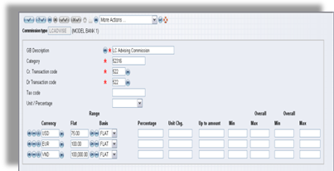  Figure 2. A Commission/Charge designer table in T24
 | Auto revaluation of FCN liabilities to reflect the true exposure. Liability to reflect tolerance as default but option of not booking Tolerance. | 1 | 5 | Supported by T24. FCN assumes to mean Foreign Currency Notes.
 | Ability to handle consolidated limits/provide various credit facilities/Sub facilities when Group of Companies are involved | 1 | 5 | Supported by T24.
 | Automatic linkage between the Trade module and the bank’s Risk Monitoring system for information to analyse and ascertain the "Risk Situation" of the applicant's account and whether the facility limit is secured. |  | 4 | T24 provides an interface mechanism to permit linking of T24 to external systems. The mechanism is called Open Financial Service (OFS). Interfaces can be built between relevant systems of Bank and T24 for Accounting and other purposes. OFS is an interface that allows transactions and queries requests to be processed by T24. Various connectivity options are supported for communicating with OFS. OFS is the single point of entry to T24. Every single interaction with T24 is driven through OFS.
 | Log pending documents to the relevant LC. Weekly report of it to be generated. | 1 | 5 | Supported by similar T24 standard reports or enquiries.  A Bank user can also utilize either T24 Enquiry designer or T24 Report Designer to construct a report. The report can be in the form of online enquiries (i.e. using T24 Enquiry designer) or in the form of hardcopy reports produced during a Close of Business. In addition, T24 Enquiry designer includes a wizard function to guide a user to design simple enquiries.
 | Ability to produce similar LC’s many times with different LC Numbers. | 1 | 5 | Supported by T24.
 | Generates a Reimbursement Authorisation in either Swift, telex or mail formats for the reimbursing bank to honour the claim from negotiating bank. The authorisation is generated when reimbursing bank and the advising bank are not the same. | 1 | 5 | Supported by T24. System provide DELIVERY module to manage outgoing message in different communication channels, including SWIFT message
 | L/C Amendments
 | Provides facility to generate Amendment to LC in the predefined format by mail or by cable/telex/Swift. | 1 | 5 | Supported by T24.
 | Updates the customer's utilisation for the difference and generate advice to reimbursing bank based on user-defined format when there is amendment to the amount. Generates the appropriate accounting entries. | 1 | 5 | Supported by T24.
 | Checks to ensure that the new expiry date is not later than the limit expiry date and generate Advice to reimbursing when there is amendment to LC expiry date. | 1 | 5 | Supported by T24.
 | Generates accounting entries for collection of commission, cable/telex if any and postage for all amendments. | 1 | 5 | The system support defining and processing charge/commission for a specific transaction/customer, including generating accounting entries in customer and P/L account.
 | Ability to effect internal amendments suppressing delivery messages. | 1 | 5 | Supported by T24 Trade Finance module.
 | LC amendment by a value reduction. Should collect standard text charges but update limits accordingly upon acceptance by beneficiary. | 1 | 5 | Supported by T24 Trade Finance module.
 | Ability to amend LC type. Sight to Usance and vice versa and any other user defined swift field  Eg: Beneficiary’s name, Reimbursing Bank, Doc’s Required etc | 1 | 5 | Supported by T24 Trade Finance module.
 | Cancellation of LC and closure of account
 | Cancels LC automatically (unless SG/AD issued but originaldox/ negotiation not received),  When the LC has expired and after a lapse of a pre-defined grace period and has not received any instruction to extend the LC, generate report for X day before expired L/C and advise to customer for decision. | 1 | 5 | Supported by T24 Trade Finance module
 | Ability to cancel before Expiry of the LC. | 1 | 5 | Supported by T24 Trade Finance module
 | Generates reversal accounting entries and update customer's utilisation upon LC cancellation and closure of account. | 1 | 5 | Supported by T24 Trade Finance module
 | Able to reinstate a cancelled LC upon extension of expiry date or for negotiation of documents arrived after expiry date. | 1 | 5 | Supported by T24 Trade Finance module
 | Closes LC contract and update customer’s utilisation upon initiation of Bills Negotiated. | 1 | 5 | Supported by T24 Trade Finance module (Drawings under Import LC)
 | Advice of charges received from correspondent | 1 | 5 | Support by T24 Delivery module.
 | Captures and generates the appropriate accounting entries based on SWIFT message for the following charges:-  · Amendment commission;  · Advising commission;  · Confirmation commission; and  · Cable/telex charges. | 1 | 5 | The system supports definition and processing of charges/commissions for a specific transaction/customer, including generating accounting entries in customer and P/L account.
 | If the payment mode is through the customer deposit account, debit the deposit account for the charges and generate a Debit Advice. | 1 | 5 | Supported by T24
 | Generates report listing of LC opened for either a specified client, nature of goods (BTN No / Internal index for commodities), country, advising bank, currency type, etc. | 1 | 5 | T24 has similar enquiries/reports which are produced using T24 Trade Finance module. We are assuming that the format of these enquiries and reports meet the requirements of NDB Bank. If not, then NDB Bank can use T24 Enquiry and Report designer tools to modify them.  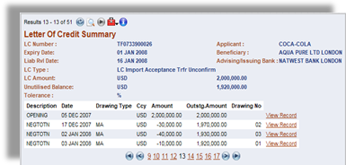  Figure 3. LC Summary
General Requirements
 | Trade terms should be cross checked automatically with conditions | 1 | 5 | T24 supported to check some important term in LC automatically by TF module.
 | Ability to debit rupee amounts, converted to FCY from FCBU clients while entering an L/C for FCBU customer (eq stamp duty) in one and the same input | 1 | 5 | T24 is a multi currency system, where every product can be defined in various currencies
 | Release SWIFT / Telex / Fax /E.mail/ Mail messages after final approval instantly (at option). | 1 | 5 | Supported by T24.
 | Pending transactions (not released by system) to be added to new transaction for which credit approval is to be obtained. | 1 | 5 | Supported by T24 Trade Finance module.
 | Handle forward and backward value dates for:  Debiting/crediting customer’s account.  Debiting/crediting Nostro and Vostro account. | 1 | 5 | Supported by T24 Trade Finance module.
 | All data validation performed on line at processing level | 1 | 5 | Supported by T24.
 | On line performance of all types of Fee calculations/Tolerance | 1 | 5 | Supported by T24 Trade Finance module.
 | Print acknowledgment advice to customer | 1 | 5 | Supported by T24 Delivery module.
 | For branch transactions a copy of the advice be printed at the branch | 1 | 5 | Supported by T24 Delivery module.
 | Facility to input Insurance policy No. for non-CIF LC’s  (Input: LC No and Insurance Policy No.) and Also import licences | 1 | 5 | Supported by T24. Other fields may be added as local fields using the Local Reference (Database Designer) tool.  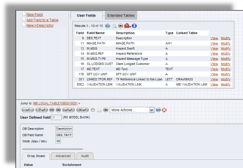  Figure 4. Database Designer
 | Refer to A/C Officer electronically for Credit approval when required. | 1 | 5 | Supported by T24.
Open Insurance cover or Blanket cover
 | Outstanding LC value at any given time should not exceed the cover | 1 | 5 | Supported by T24 Trade Finance module.
 | Renewal notice 30 days before expiry date of the cover | 1 | 4 | Supported through customization.
 | Mandatory input fields to be minimized to increase turnaround time. Ability to copy similar type of LC’s. Ability to enter an applicant under a different customer limit. (eq. NDB customers)  Advice should also print the real applicant name together with the limit customer | 1 | 5 | Supported by T24 Trade Finance, Limit and Delivery modules.
 | Facility to collect Margins through the L/C Module with an indicator field to state Margin Collect Yes/No ‘Y’,’N’ and automatically debit customer account or suspense a/c (where cash margins are collected from clients) with the respective value At Opening and Amendment. (Percentage of margin to be determined)  Balance of suspense a/c should be zero at the end of the day.  A report to be generated if any outstanding remains end of the day. | 1 | 5 | Supported by T24 Trade Finance module.  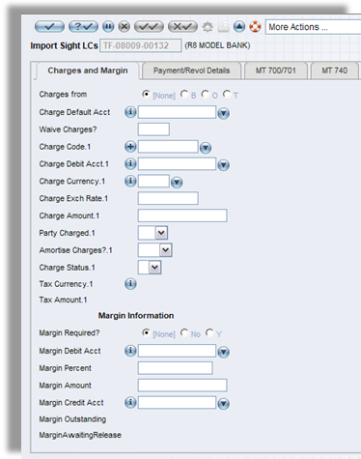  Figure 5. Margin
 | Facility to issue Shipping Guarantee. (Input: L/C No. name of carrying vessel, B/L No. and date, port of loading, port of discharge, details of goods, shipping marks and amount | 1 | 5 | Supported to issue of Shipping Guarantee by T24 Trade Finance module.  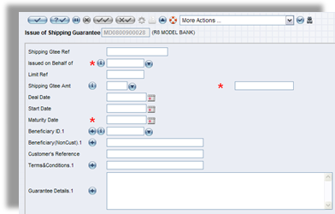  Figure 6. Issued of Shipping Guarantee
 | Facility to Issue Advance Documents (as same as SG above) | 1 | 5 | Supported by T24 Trade Finance module.  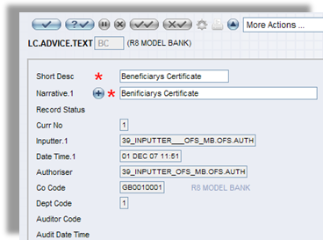  Figure 7. LC.ADVICE.TEXT
 | Transactions approval: Display transaction(s) pending for approval, Refer to A/C officer electronically for approval where required. If the particular officer is not available refer to the next officer/flash the sender or inputter after some time. | 1 | 5 | Supported by T24 Trade Finance module.  Transactions will be referred to all officers who have responsibility.
 | Banned Commodities | 1 | 4 | Supported through customization.
 | Government restriction clauses | 1 | 4 | Supported through customization.
 | facility conditions | 1 | 5 | Supported by T24 Trade Finance module.
 | Variable Fx rates | 1 | 5 | Supported by T24 Treasury module.
 | Facility Conditions. | 1 | 5 | Supported by T24 Trade Finance module.
 | Ability to selectively generate outside standard reports. | 1 | 5 | A Bank user can utilize either T24 Enquiry designer or T24 Report Designer to construct a report. The report can be in the form of online enquiries (i.e. using T24 Enquiry designer) or in the form of hardcopy reports produced during a Close of Business. In addition, T24 Enquiry designer includes a wizard function to guide a user to design simple enquiries.
 | Import Licenses | 1 | 5 | Supported by T24 Trade Finance module.
 | Controls
 | Application interaction  Applications for L/Cs  L/C details received  Payments  General ledger system  Treasury Application  Customer Information File | 1 | 5 | Supported by T24.
 | Once the account number is entered. Display title of Account, name(s) of authorised signatory/ies, Specimen Signatures and import license expiry date. | 1 | 5 | T24 provides a trigger functionality which upon input details to a specific field such as the account number field will trigger display of appropriate information such as specimen signatures.
 | Allocate Registration number | 1 | 5 | Supported by T24 Trade Finance module.
 | Refer to A/c Officer electronically for approval where required. | 1 | 5 | Supported by T24 Trade Finance module.
 | Facility to input Insurance policy No. for non-CIF LCs (Input: LC No and Insurance Policy No.) | 1 | 5 | Supported by T24 Trade Finance module. Other fields may be added as local fields using the Local Reference (Database Designer) tool.
 | Allocate Registration number for all import licenses with facility to update L/C Status | 1 | 5 | Supported by T24 Trade Finance module.
 | Diaries to follow up with Customer/negotiating bank for non-receipt of documents.(Shipping Guarantees Taken, Advance Taken) Produce tracer by swift / telex/fax to Customer/ negotiating bank on diarised date. | 1 | 5 | Supported by T24 Trade Finance and Delivery modules.
 | Ability to Fax the negotiation advice to customer at option. | 1 | 4 | Integration with Fax will require interface customization.
 | Auto check on live SWIFT keys when ever an authenticity is required | 1 | 5 | Supported by T24.
 | Cancel fully/partially utilised L/Cs 30 days after expiry date provided no outstanding bills or transactions exist. | 1 | 5 | Supported by T24 Trade Finance module.
 | Generate necessary entries i.e. reversal of outstanding liability, margin (if any), commission on fully unutilized L/Cs as per tariff. Update Limit Module /CIF. | 1 | 5 | Supported by T24.
 | Print cancellation advice. | 1 | 5 | T24 has a module called Delivery module which handles the formatting and auto generation of different types of advices. The advice can be configured as per the bank’s requirements.  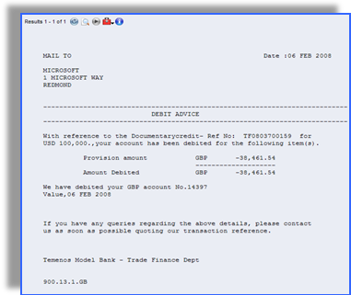  Figure 8. Customer Advice Sample (Auto Generated)
 | Print advices/ Copy of the LC at Branch /HO level at any given time even past records. | 1 | 5 | Supported by T24 Delivery module.
 | Fax cancellation advice, debit/credit advice to opener indicating unutilized amount. (advice client via Fax or E-mail) | 1 | 4 | The T24 Delivery module supports all standard SWIFT Messages/Print Messages.  Integration with Fax and email will require interface customization.
 | Reports
 | Outputs and reporting requirements –Should Be Online/Report/Inquiry | 1 | 5 | Supported by T24
 | Payments | 1 | 5 | T24 has similar enquiries/reports. We are assuming that the format of these enquiries and reports meet the requirements of NDB Bank. If not, then NDB Bank can use T24 Enquiry and Report designer tools to modify them.  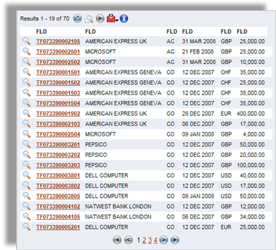  Figure 9. List of Sight Payment under Import LC
 | Daily activity report | 1 | 5 | T24 has similar enquiries/reports. We are assuming that the format of these enquiries and reports meet the requirements of NDB Bank. If not, then NDB Bank can use T24 Enquiry and Report designer tools to modify them.  (Please refer to 31 above for illustration of the LC Summary).
 | Outstanding L/C report (Customer/Currency/Amount/Country/Confirmed) | 1 | 5 | List of outstanding LCs is available as a standard report in the T24 Model Bank. The enquiry / report can be modified to display any additional information contained in the application.  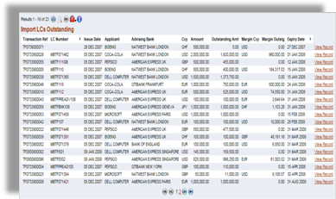  Figure 10. Import LCs Outstanding Report (Model Bank)
 | Exposure reports by Customer and Country | 1 | 5 | Supported by T24 Enquiry and Report designer tools
 | Customer Statements | 1 | 5 | Supported by T24.  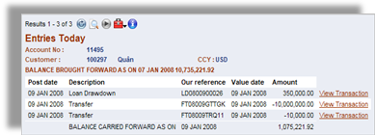  Figure 11. Customer Statement Entries Today
 | Diary of forthcoming events. | 1 | 5 | Supported by T24 through Global view of customer.  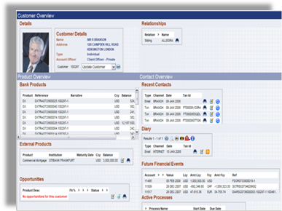  Figure 12. Global View of customers
 | Print customer position showing reason for referral such as, limit expired, limit exceeds etc. where credit approval required. | 1 | 5 | Supported by T24.  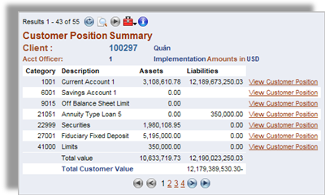  Figure 13. Customer Position Summary
 | Daily processed reports to form a part as a register for each product giving details  -.Customer Name  -.Reference no  -.Currency and amount  -.Expiry/due Dates  -.confirmed/ unconfirmed,  -.advising bank,  -.under license/not under license  -.Tenor-by sight, acceptance, deferred payment or mixed payment  -.Commodity  -.Event | 1 | 5 | T24 has similar enquiries/reports. We are assuming that the format of these enquiries and reports meet the requirements of NDB Bank. If not, then NDB Bank can use T24 Enquiry and Report designer tools to modify them.  (Please refer to the answer of above question No. 31 for illustration of the LC Summary).
 | Turnover report compared with previous month/year per Customer | 1 | 3 | A Bank user can utilize either T24 Enquiry designer or T24 Report Designer to construct a report. The report can be in the form of online enquiries (i.e. using T24 Enquiry designer) or in the form of hardcopy reports produced during a Close of Business. In addition, T24 Enquiry designer includes a wizard function to guide a user to design simple enquiries.  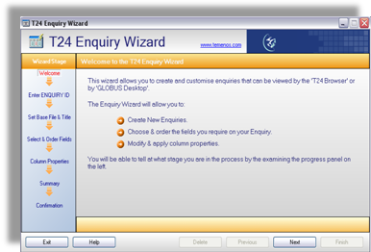  Figure 14. T24 Enquiry Wizard to guide users in designing enquiries
 | Profitability Report – Calculation Of Commission/Interest Earned | 1 | 4 | Please refer to the above Response.
 | Outstanding L/C’S | 1 | 5 | Please refer to the Response No. 73.
 | Overdue Payments; | 1 | 5 | Supported by similar standard T24 enquiries and reports generated in its Past Due module.
 | Non-Performing Customers | 1 | 5 | Supported by similar standard T24 enquiries and reports generated in its Past Due module.
 | Outstanding Letter Of Credit As At Date, Month, Year; | 1 | 5 | Supported by similar standard T24 reports and enquiries.
 | Commitment With Banks; | 1 | 5 | Supported by similar standard T24 reports and enquiries.
 | LCs Issued/Bills Negotiated Under LC During the Month; | 1 | 5 | Supported by T24 Trade Finance module.
 | Listing Of Authorisations and Utilisations - All Accounts; | 1 | 5 | Supported by T24 Trade Finance module.
 | Report Interlink with Margin, Shipping G’tee, Adv Endorsed, Acceptance, Negotiation | 1 | 5 | Supported by similar standard T24 reports and enquiries.
 | Able to provide reports for the following reporting levels:-  Customer; product type; branch;, overall bank level; and etc. | 1 | 5 | Please refer to the Response No. 79.
 | Provides facility to present statistical reports for management review.  Total Outstanding Import L/C -By Customer  Total Issued  Total by Correspondent Bank  Credit Line Exceeded  Customer Profitability  Outstanding By Business type  Customerwise utilization | 1 | 3 | Please refer to the Response No. 79.
 | Soft storing of L/C copies electronically | 1 | 5 | Supported by T24 Trade Finance module.
 | Functional requirements import negotiations
 | To be able to generate a fax/e-mail of the Discrepancies (if any) to clients/branches after details are logged in the Negotiation Module.(Including the date of receipt of the original doc) | 1 | 4 | The T24 Delivery module supports all standard SWIFT Messages/Print Messages that can be used to Fax/Email.  Integration with Fax and email will require interface customization.
 | Fax/email to client indicating Clients/Branch Fax No., Branch Name and Contact persons | 1 | 4 | Please refer to the above Response.
 | Advice of refusal (MT734) to be generated on the fourth working day from receipt of original documents by default. (with the exception of deleting, creating and amending messages if required) | 1 | 5 | Supported by T24 Trade Finance and Delivery modules.
 | Charges to be calculated/debited on the existing tariffs or offer letter and to be able to charge any additional fees if required, (at least three) with the facility to debit charges to any other A/C (Parent Company etc) | 1 | 5 | Supported by T24 Trade Finance module.
 | A category code to be inputted to identify whether reimbursement is claimed or Proceeds to remitted as per L/C terms.  CAT  EG : -  Clean documents where proceeds to be remitted - LCRM  Clean documents with reimbursement - LCRB  Discrepant docs with reimbursement - LCRD | 1 | 5 | Supported by T24.
 | Upon acceptance of discrepancies client to be debited after exchange rate is obtained from treasury dept (bill plus charges) and respective Nostro accounts to be credited automatically of the currency of the L/C and Swift/Telex messages to be created depending on the reimbursement instructions | 1 | 5 | Supported by T24 Trade Finance module.
 | When reimbursement to be claimed, MT752 to be generated | 1 | 5 | Supported by T24 Trade Finance and Delivery modules.
 | When proceeds to be remitted – MT202 , MT756 (payment advice) to be auto generated. Option to deduct our charges.  (Fields are required to enter Swift codes of Beneficiary Bank, Their correspondent, account no etc) | 1 | 5 | Supported by T24 Trade Finance and Delivery modules.
 | At the time of debiting the account with the Bill, a message to appear with regard to the availability of funds (automatic check of the balance) and a message to be generated or transaction to be routed to Credit Authorisation Officer. | 1 | 5 | Supported by T24 Dispo feature.
 | When IBR’s are booked on receipt of Negotiation advices (MT754) from negotiating bank | 1 | 5 | The T24 Delivery module support all standard SWIFT Messages/Print Messages
 | Automatically Nostro A/C to be picked of the Currency of the Credit and the IBR A/C of the L/C opener to be debited (Accounts to be changed if required) { FALLING UNDER CAT – LCRB above) | 1 | 4 | Supported through customization.
 | When IBR’s are booked on receipt of MT742 from Nego Banks (FALLING UNDER CAT – LCRM) | 1 | 5 | The T24 Delivery module supports all standard SWIFT Messages/Print Messages
 | Relative messages to be auto created. (MT756 and MT202) | 1 | 5 | Supported by T24 Delivery module.
 | To able to get a listing of advance documents endorsed/Shipping guarantees issued with Amounts, Date and L/C No. in order to debit client’s a/c direct on receipt of the Negotiation advices (MT754, MT742) | 1 | 5 | Supported by T24 Trade Finance and Delivery modules.
 | To able to get outstanding of amounts pending in Import Bills Receivable accounts at any time. | 1 | 4 | Supported through table configuration and/or customization.
 | To get a total no of IBR’S booked during a month. | 1 | 4 | Supported through table configuration and/or customization.
 | Provisions of Transitory interest to be calculated at the end of the month or any given date automatically with the details | 1 | 4 | Supported through table configuration and/or customization.
 | Printout of same as above including Clients Name, L/C no., Amounts, Interest amounts, accounts debited and Credited | 1 | 4 | Supported through table configuration and/or customization.
 | Transit interest to be calculated automatically from value date (Nostro debit date) to the day of settlement. | 1 | 4 | Supported through table configuration and/or customization.
 | If Margin was collected charge interest automatically for the shortfall and / or for the period margin was not collected where Nostro a/c was debited before the Margin taken date. | 1 | 4 | Supported through table configuration and/or customization.
 | If LC margin was taken or where goods are cleared under Advance docs/Shipping G’tee margins to be reversed automatically when debiting client for the bill. (should not go for overrule.) Excess /shortfall to be recovered from C/A automatically. | 1 | 5 | Supported by T24 Trade Finance module.
 | To be able to check the history of transactions. (Should be pending for at least three months) | 1 | 5 | Supported by T24 Trade Finance module.
 | Printouts to be reprinted/generated at any time. | 1 | 5 | Supported by T24 Delivery module.
 | Report of Docs received during the last 6 or 7 days. | 1 | 5 | Supported by T24 Document Management module.
 | Inward mail to be captioned in the system  Trade dept should be able to track the settled and pending bills from this system | 1 | 5 | Supported by T24
 | IMPORT ACCEPTANCE
 | Signature verification option should be available to verify signatures in Bills of Exchange or Letters  of undertaking. | 1 | 5 | Supported by T24. The Image Management application in T24 provides the ability to capture images and to associate multiple images with records within T24. Images can be attached to any record including customer, account, loan contract etc. and the user can directly access the images from within the record. Image Management benefits the user by providing immediate access to digital copies of essential data such as signatures, loan documentation, birth certificates or passports.  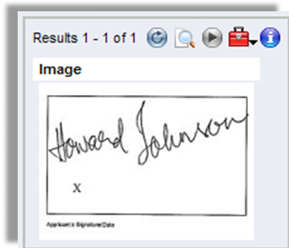  Figure 15. Signature enquiry
 | Should be able to book acceptance liability in one flow. (L/C liability reversal and booking of acceptance liability in one process/ simultaneously) | 1 | 5 | Supported by T24 Trade Finance module.
 | The liability A/C to be picked up automatically but could be changed if required  (where client has more than one A/C eg: For Import of Machinery etc....) | 1 | 5 | Supported by T24 Trade Finance module.
 | Charges to be calculated automatically on the existing tariff/offer letter and to be able to charge any Additional fees if required, (At least Three) with the facility to debit charges to any other A/C (Parent Co... etc). Stamp duty to be calculated depending on the usance period. (At different Duty rate.) | 1 | 5 | Supported by T24 Trade Finance module.
 | Field required to input Beneficiary bank and their Correspondent where proceeds to be Remitted as per L/C terms. | 1 | 5 | Supported by T24 Trade Finance module.
 | Relative messages to be generated automatically. | 1 | 5 | Supported by T24 Delivery module.
 | *Swift/Telex msg confirming due date.  1.Where proceeds are to be remitted  2.Where nego bank has to claim proceeds | 1 | 5 | Supported by T24 Delivery module.
 | *Authorisation to reimburse bank where reimbursement is allowed as per L/C terms.  (Correct Correspondent to be picked along with other details) | 1 | 5 | Supported by T24 Trade Finance module.
 | ** Msgs could be amended if required. | 1 | 5 | Supported by T24 Delivery module.
 | Printouts / Debit advices to be generated automatically when authoriser authorise the transactions at HO/Branch level. | 1 | 5 | Supported by T24 Delivery module.
 | (Exchange rate, Cross rates, Branch Name, Client Name, Charges, Total debit required on same or if a particular client requires any additional details to be included ) | 1 | 5 | Supported by T24 Delivery module.
 | Maturity dates to be advised to clients one week prior to Due date via Letter/Fax | 1 | 5 | Supported by T24 Delivery module.
 | Messages to be generated in the system three working days prior to due date where proceeds are  to be remitted with the value date as the due date with exception of creating messages if there is a change. Message types - MT756, MT202 | 1 | 5 | Supported by T24 Delivery module.
 | Due bills to appear on inputter and authorisers screen on due date and a report of same to obtain  Exchange rates from treasury Dept. Dealer to input the rate & Value date  (Customer Name, L/C No., Bill amount, Value date and Reimbursing Bank required) | 1 | 5 | Supported by T24 Trade Finance module.
 | All transactions to be updated on in the treasury dept once transactions are authorised (exchange rates and positions) and report on request. | 1 | 5 | Supported by T24.
 | Following details should be updated : Clients Name, L/C No., Currency, Amount, Reimburse Bank, Exchange rate, Account Nos, Value date | 1 | 5 | Supported by T24 Trade Finance module.
 | Should be able to get reports of acceptance as follows,  Customer o/s on a daily, weekly and monthly basis (L/C No, Start Date, Due date, Tenor, Negotiating bank, Amount, Currency etc.  To be able get turnovers of acceptance booked monthly/ and annually per Client/Branch when required.  Generate statements/outstanding of client in a fax format of individual clients (if requested by clients)  Printouts to print in respective branches | 1 | 4 | A Bank user can utilize either T24 Enquiry designer or T24 Report Designer to construct a report. The report can be in the form of online enquiries (i.e. using T24 Enquiry designer) or in the form of hardcopy reports produced during a Close of Business. In addition, T24 Enquiry designer includes a wizard function to guide a user to design simple enquiries.
 | Report to generate at treasury dept on a weekly basis giving details of the usance bills falling due for the following week. (Report should indicate the Clients Name, L/C No., Currency, Amount, Reimburse Bank, Value date) | 1 | 4 | T24 has similar enquiries/reports. We are assuming that the format of these enquiries and reports meet the requirements of NDB Bank. If not, then NDB Bank can use T24 Enquiry and Report designer tools to modify them.  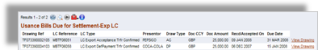  Figure 16. Usance Bills
 | Printouts/advices to be reprinted/generated at any time | 1 | 5 | Supported by T24 Delivery module.
 | Option to autorisation by Swift to lift reserve. | 1 | 5 | Supported by T24 Delivery module.
 | Inquiry : Treasury/RMCD/Trade to see all due bills at any time. | 1 | 4 | A Bank user can utilize either T24 Enquiry designer or T24 Report Designer to construct a report. The report can be in the form of online enquiries (i.e. using T24 Enquiry designer) or in the form of hardcopy reports produced during a Close of Business. In addition, T24 Enquiry designer includes a wizard function to guide a user to design simple enquiries.
 | Functionality of Bill Financing-Import/Exports (PACKING CREDITS/STL/BILL PURCHASES)
 | Types of Financing required : - Any type of Financing should be available.  a. Export bill Under L/C  b. Export Bill not Under L/C  c. Packing Credit loan on LCs or Confirmed order  d. Short term Import Loans Under L/C  e. Short term Import Loans Not Under L/C  f. Any Other Import/Export Financing eg: Usance bills availization or Discount of Import Collection-usance bills  h. Re-discounting any Export bills  i. Vendor finance  J. Discounting of Receivable/ Payable/ Acceptance | 1 | 5 | Supported during implementation by parameter configuration
 | The above types of financing/loans should be defined with category code for detail breakups of each financing. | 1 | 5 | Supported during implementation by parameter configuration
 | Financing should be available from any module. Eg; when settle an import bill, or collection docs, System should request for finance or not, and continue the transactions. If financing required as one transactions. | 1 | 5 | Supported by T24.
 | The related ref of Credit or Collection should be automatically displayed on the transactions when financing such transactions, which can be prior to the transactions. date. | 1 | 5 | Supported by T24.
 | The period should be defined by start date and due date with options to blank due date or due date to calculate from the effective start date when the tenor is stated. | 1 | 5 | Supported by T24.
 | The system should identify due date that fall on holidays and give the next business day automatically.  If the holiday is a local holiday the system should pick the previous working day.  Depending on the nature of the transaction and the currency of that transaction system should alarm the inputter if the due date falls on a holiday.  Eg: If a export bills is financed in USD the system should check whether the due date falls on a holiday in the USA | 1 | 5 | Supported by T24.
 | Base Rate for Interest should be maintained for easy amendment to a rate change across the product | 1 | 5 | Supported by T24.
 | Interest rate should pick from the Fee tariff with automatic adjustments to the overdue rate in the system for each type of transaction or else the past due rate should be an independent fee code to the base rate. | 1 | 5 | Supported by T24.
 | Rate Codes to identify rates used by the system.  Eg :- Rate Code  50 Standard Rate input by RMCD  51 Special Rate by Trade Dept at the time of transactions.  52 Normal Past Due Rate – Fixed rate input by RMCD  53 Special Past Due Rate – Input by Trade Dept. at the time of transactions.  54 Rate link to standard rate with a spread e.g; 5pct plus the standard rate | 1 | 5 | Supported by T24 SMS module.
 | Once a bill is overdue adjustments to Interest rate and new Dues to be allowed as a amendment to the original loan | 1 | 5 | Supported by T24.
 | The interest calculation should be to the actual number of days/period and defined by a frequency code | 1 | 5 | Supported by T24.
 | Interest calculation to allow for tax (BTT/DL/NSL) collection WHEN EVER INTEREST IS SETTLED fee on fee to be charged. | 1 | 5 | Supported by T24.
 | When financing is done in foreign currency ex rate conversion to local currency and at time of settlement transactions to facilitate forward booking to be used for settlement of loan. | 1 | 5 | Supported by T24.
 | Bill tenors to be in a two character mode  BL=Bill of Lading  ID=Invoice Date  ST=Sight etc | 1 | 5 | Supported by T24.
 | Interest Frequency code to be in a one character mode  M=Monthly  Q=Quarterly | 1 | 5 | Supported by T24.
 | Other charges such as Negotiation commission, Telex, courier etc to be collected on the same transaction.(Fee Code and charges fields) with allocation code to denote from whom the charges to be collected. Eg B=Buyer, D=deduct, W=waive etc | 1 | 5 | Supported by T24.
 | Rollover function to be allowed with changes to Interest rate/due date, change of financing type on due date or after with back valuation. | 1 | 5 | Supported by T24.
 | System should have approved tenor for the clients on B/F module so that any finance (Loans/Discount) exceeds approved tenor period transactions is referred to Risk Management and Control Department with a notification to the Relationship Manager. | 1 | 4 | Supported with minor local enhancement.
 | Amendments to be allowed on the due date or prior to due date for re-discount a bill under same bill/loan ref. with same or new rate. | 1 | 5 | Supported by T24.
 | Interest taken at the time of discounting to be refunded if required  Eg: 1.Bill discounted for 100 days @ 10%  Bill paid in 95 days  Interest for 5days to be refunded 8.5%  Balance to be credited to income A/C  Eg: 2.Special case  Bill discounted for 45 day @ 10%  Client requests to re-discount bill on 30th day for further 30day (Total period  60days)and re-discount for a further 30days  System should allow to refund the total interest for 15days at same rate or at a lesser rate (8.5%) as above. | 1 | 5 | Supported by T24 Trade Finance module.
 | Report on the following  *Customer o/s with customer current position to credit limit  *Amount and Currency with start and due date  *Interest Rate  *Interest Debited  *Interest rate changes  *tenor  *status | 1 | 4 | T24 has similar enquiries/reports. We are assuming that the format of these enquiries and reports meet the requirements of NDB Bank. If not, then NDB Bank can use T24 Enquiry and Report designer tools to modify them.
 | Reports of outstanding loans and overdue loans of individual clients to be taken at any given period/time. And on weekly/monthly basis in fax format of particular clients. | 1 | 5 | T24 has similar enquiries/reports. We are assuming that the format of these enquiries and reports meet the requirements of NDB Bank. If not, then NDB Bank can use T24 Enquiry and Report designer tools to modify them.  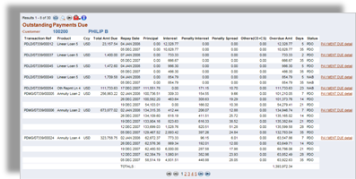  Figure 17. Outstanding Payments Due  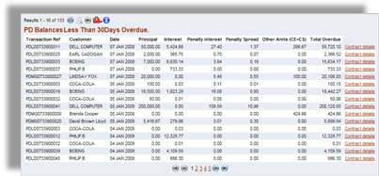  Figure 18. PD Balances Less Than 30Days Overdue
 | Generates reminder X number of days before maturity. Able to generate subsequent reminders every X number of days after maturity until settlement or the loan TR is extended. | 1 | 4 | Supported by T24 Delivery module and Chaser feature.
 | Reminder should be in a fax / e.mail format so that is could be faxed or e.mailed and should have the following details;  Loan ref, Clients name. fax no., contact party, clients reference, due date, interest rate etc. and a report of same For follow ups with account managers | 1 | 4 | The T24 Delivery module supports all standard SWIFT Messages/Print Messages that can be used to Fax/Email.  Integration with Fax and email will require interface customization.
 | Advices/Printouts to be reprinted at any time | 1 | 5 | Supported by T24 Delivery module.
 | Detail breakdown of charges to be indicated on advices and such advice should indicated the principal loan amount, amount settled/recovered and the outstanding amount | 1 | 5 | Supported by T24 Delivery and Trade Finance modules.
 | For bills financed : advices should indicate the bill due date and the discounted due date | 1 | 5 | Supported by T24 Delivery module.
 | SHIPPING GUARANTEES
 | Facility to issue Shipping Guarantee. (Input: L/C No. name of carrying vessel, B/L No. and date, local agent/shipping line and amount) | 1 | 5 | Please refer to the explanation 47 above.
 | System to auto check whether relevant docs being received at the bank when applied for S/G.(Availability to input data on receipt of original docs) when L/C No, Amt, Inv. No, or B/L-AWB No is given visa versa. | 1 | 5 | Supported by T24 Guarantees module.
 | Customer Invoice No, Airway Bill No and B/L no should be entered so that time of booking collection highlight any S/ G OR Advance docs taken. | 1 | 5 | Supported by T24 Guarantees module.
 | Liability should be booked for 300% of the invoice value or as per the special requirements of the shipping line. Outstanding reports should give the percentage (of invoice value) | 1 | 4 | Supported by T24 Guarantees module, Limit sub-system. Some local enhancement may be required depending on the complexity of the details of the special requirements and the handling of invoices.
 | When relevant data is given system to call for margin except Special clients/Usance L/C/L/C margin taken already. If LC margin is less than the invoice amount System to recover the difference. Margin to SG margin a/c. |  | 5 | Supported by T24 Guarantees and TF modules.
 | If requested for loan, Loan to be granted to SG margin a/c directly. | 1 | 5 | Supported by T24 Guarantees module.
 | Check for LC balance for Negotiation and mark SG issued amount. |  | 5 | Supported by T24 Guarantees module.
 | Upon issuance of S/G confirmation of issuance to be notified to Shipping line by the system via fax connectivity. System to have a shipping line agents database with fax nos. |  | 4 | Please refer to the Response No. 161.
 | Generate necessary entries: i.e.  Automatically margin A/C No and C/A or Loan a/c No to be picked and what percentage (if no existing a/c is available automatically respective a/c and to be generated. If no sufficient funds auto direct to Credit Authorization Officer/Branch/account manager’s approvals.  Dr. customer, Cr. L/C margin, commission , postage (Sight L/C)  Margin to be taken on invoice value @ imports selling to be roundup to nearest thousand  Commissions, BTT, NSL (or any other taxes) should be calculated automatically using invoice value and credited to the relevant accounts. NSL/any other taxes to be charges on Comm + BTT  If the stamp for RS 100.00 not provided by the customer, to included in the fees.( ADDITIONAL FIELDS) | 1 | 5 | Supported by T24 Guarantees and TF modules.
 | All commissions (charges) to get automatically calculated as per the details given per offer letter/tariff to system | 1 | 5 | Supported by T24.
 | Additional Commission depending on client to be charged on a monthly/quarterly basis after issuance on  S/G on relevant customer tariffs automatically. | 1 | 5 | Supported by T24.
 | S/G liability to be automatically booked and could be able to book on parent company liability etc. | 1 | 5 | Supported by T24 Guarantees module.
 | Print Shipping Guarantee Approval advice. | 1 | 5 | Supported by T24 Delivery module.
 | If the particular customer wants SG issued for a particulate month or outstanding list to be printed by using customer name. | 1 | 5 | Supported by T24 Guarantees module.
 | All the branch approvals should be ON-LINE SYSTEM and advises to generate on the respective branch. All relevant data could be taken at a branch. | 1 | 5 | Supported by T24 Delivery module.
 | System to automatically charge commission for each month and advice generated with reminder to the customer (tracer). (if shipping guarantee is not canceled with in a month)  (option available to select monthly commission/qtr comm. etc.) | 1 | 5 | Supported by T24.
 | To generate report at any given time with all outstanding gtee's issued per customer on a shipping line/ per Branch with comm. earned, taxes paid, guarantee ref. Nos., Next comm. due, whether original docs received or non/shipping co. etc. an guarantees issued as a whole. | 1 | 5 | Supported by similar standard T24 reports and enquiries.  A Bank user can also utilize either T24 Enquiry designer or T24 Report Designer to construct a report. The report can be in the form of online enquiries (i.e. using T24 Enquiry designer) or in the form of hardcopy reports produced during a Close of Business. In addition, T24 Enquiry designer includes a wizard function to guide a user to design simple enquiries.
 | Reminder to get generated on outstanding S/G per customer at a given time with docs. Received date. | 1 | 4 | Supported through customization.
 | List of S/G’s not cancelled after receipt of original docs and collection of same from bank | 1 | 4 | Please refer to the Response No. 181.
 | Using guarantee number and report to be generated by the authorizer end of day for G’tees cancelled during the day | 1 | 4 | Please refer to the Response No. 181.
 | A separate data base giving contact person, company contact nos., fax nos. stored and subject and relevant msg. on selection to get selected when customer requests info. Regarding bills/G'tees/outstanding commissions etc. at a given time should be printed instantly to be faxed or posted to customer. | 1 | 4 | Please refer to the Response No. 181.
 | Relevant data could be obtained G'tee wise, S/co. wise Commission earned/taxes collected/ group wise etc. at any given time/period. | 1 | 4 | Please refer to the Response No. 181.
 | Advance documents
 | To input the number  Option to issue under LC or non-LC  If it under LC place to input the LC number  If it under DA/DP to pick the running ad reference number | 1 | 5 | Supported by T24.
 | If it under LC to check the  LC expiry date  LC balance  Sight or d/a | 1 | 5 | Supported by T24.
 | The system should identify margin required or not  Margin of 100 pct or more and input field for pct. Of margin | 1 | 5 | Supported by T24.
 | Previous negotiation pending with s/g outstanding.  LC margin outstanding  Pending original/Shipping Guarantee cancellation | 1 | 5 | Supported by T24 TF module.
 | Option to enter the invoice number and date / B/L number and date/ Air Way Bill number and date (option to input the date too) | 1 | 5 | Supported by T24 TF module.
 | * to check the margin is required or not (as per the tariff/special clients and usance LC) | 1 | 5 | Supported by T24 TF module.
 | Check LC balance for negotiation and mark advance doc amount on the LC | 1 | 4 | Supported through customization.
 | If under collection basis  By giving an option -of yes  Option to enter the value with currency and automatically calculate the margin amount in fcy/lkr with roundup value in thousands | 1 | 5 | Supported by T24 TF module.
 | When relevant data is given by system to indicate whether margin should be taken for that customer, and margin a/c current a/c number to be picked and what margin percentage to be taken if no existing a/c available automatically respective a/c to be generated. If their is no funds automatically sent to credit autorization officer/branch approval/account manager’s approvals  * indicate the valid ex.rate  *the account number  To pick the account number when the LC number or the customer short name given. Depending by the input entry (margin / liability/ current account with the currency)  The customer settlement account is necessary to appear  * narration  To be auto generated as per the given data/tariff | 1 | 5 | Supported by T24 TF module.
 | * for any reversals to be made and to make a print of the advise at any given time | 1 | 5 | Supported by T24 Delivery module.
 | * other requirements | 1 | 5 | Supported by T24.
 | If the debiting account not in LKR the debiting charges equivalent in same currency/ or any other currency, And the charges need to calculate with system rate & the government tax to be calculate as same. | 1 | 5 | Supported by T24.
 | The margin and the charges should be calculated and appear in one screen.  The customer number should be picked by the system and appear once the account number is given or viz a viz | 1 | 5 | Supported by T24.
 | Branch approvals should be on-line on the system with the author | 1 | 5 | Supported by T24.
 | Access to signatures verification system via trade module | 1 | 5 | Supported by T24.
 | A detailed advice to generated in the branch where a/c being held (at the time of debiting and all transactions being made) | 1 | 5 | Supported by T24 Delivery module.
 | Signature verification system to pop up the applicable signature of the customer according to the value/limits. The verifier upon checking and should be able to authorize the transaction online. | 1 | 5 | Supported by T24.
 | To generate report on pending advance docs at a given time. Per customer | 1 | 4 | Please refer to the Response No. 181.
 | Generate reminders/faxes/email to respective customers at a specified time/period regarding not receipt of original documents. | 1 | 4 | Supported through customization.
 | Generate report no. Of advance docs endorsed per week/month per currency with commission earned for statistic. | 1 | 4 | Please refer to the Response No. 181.
 | If original documents are not received after 30dyas or x no of day from | 1 | 4 | Please refer to the Response No. 181.
 | Issuance of S/G or endorsement of advance docs a tracer to be generated automatically. | 1 | 5 | Supported by T24.
 | Documentary collections
 | Collections –Processing And Payment | 1 | 5 | Supported by T24.
 | Imports Collections(Inward) |  | 5 | Supported by T24.  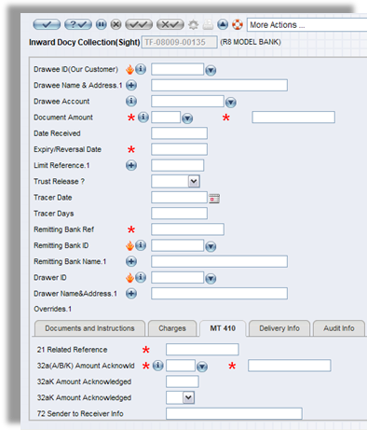  Figure 19. Inward Docy Collection(Sight)
 | COLLECTION ON D/P TERMS AND D/A TERMS | 1 | 5 | Supported by T24.
 | Coll. Reference |  | 5 | Supported by T24.
 | Status |  | 5 | Supported by T24.
 | Presented bank (input the bank name, picked up by code/short name, address ,swift should appear and allocate bank ref no.) | 1 | 5 | Supported by T24.
 | Date Received | 1 | 5 | Supported by T24.
 | Drawee (input the customer,no.,customer's address has to be picked from the system) | 1 | 5 | Supported by T24.
 | Drawer , | 1 | 5 | Supported by T24.
 | Presenting Banks Ref., | 1 | 5 | Supported by T24.
 | Amt, | 1 | 5 | Supported by T24.
 | Name of remitting bank, | 1 | 5 | Supported by T24.
 | Tenor sight | 1 | 5 | Supported by T24.
 | Maturity date should be automatically calculated. | 1 | 5 | Supported by T24.
 | Options to type invoice no. B/L no. AWB no. and the issued dates. | 1 | 5 | Supported by T24. Other fields may be added as local fields using the Local Reference (Database Designer) tool.
 | Provision to input collection details of docs received (ex: invoice, drafts, packing list) | 1 | 5 | Supported by T24.
 | Provision to input collection Instructions(ex: D/A ,D/P , charges waive) | 1 | 5 | Supported by T24.
 | Able to add correspondent bank charges to the bill value. Waive/ do not waive to indicate. | 1 | 5 | Supported by T24.
 | Advice should be generated with all these above details. | 1 | 5 | Supported by T24 Delivery module.
 | If interest called for, effective date/rate to input. Waive/do not. Advise Drawee (by fax/e.mail) & Remitting Bank (by Swift) Interest needs Exchange Control approval. | 1 | 5 | Supported by T24.
 | If the customer has taken S/Gtee or Ad docs at the time entering the { bill value/ invoice no./ B/L no./ AWB no.} the outstanding S/Gtee / SG No. and ad docs / AD No. should appear. | 1 | 4 | Supported through customization.
 | If value differs call for exceptional report. | 1 | 5 | Supported by T24.
 | Documents settlement : | 1 | 5 | Supported by T24.
 | (Input collection number, settlement account number, refusal of charges, deduction of recoveries, Nostro bank / Payee bank etc.) | 1 | 5 | Supported by T24.
 | D/P
 | When debit the customer the charges should be calculated by the system as per tariff/offer letter.(commission, telex, tax , comm. in lieu , stamp duty, account comm.)additional fields to be allocated if any charges to add later | 1 | 5 | Supported by T24.
 | IF MARGIN ALREADY TAKEN,SYSTEM TO DEBIT MARGIN AC REFUND OR DEBIT CLIENT AC FOR THE DIFFERENCE. And the customers account no. should be picked by the system.  Nostro account no. should be picked by the system. | 1 | 5 | Supported by T24.
 | Display customer’s position and specimen signature(s) of authorised signatory. | 1 | 5 | Supported by T24.
 | When input customer name and the invoice value authorised signatory who can sign upto what limit should be listed authorised. (access to Signature Verification System) | 1 | 5 | Supported by T24.
 | All the branch approval’s should be on line on the system. | 1 | 5 | Supported by T24.
 | Any branch should be able to generate arrival advise , debit advices at given times. | 1 | 5 | Supported by T24.
 | Generate related financial entries - Credit Nostro – Debit customer, Credit Comm. Postage, telex (on line). | 1 | 5 | Supported by T24.
 | D/A
 | Against acceptance of the draft account charges should be automatically calculated (acceptance Commission, Collection Comm, telex charges, tax, stamp duty at prevailing rate) as per tariff (Centralized) | 1 | 5 | Supported by T24.
 | Margin to be refunded if margin is taken on Shipping guarantee or advanced documents. | 1 | 5 | Supported by T24.
 | Automatically to create a MT412 to the presenting bank, when acceptance is booked. (presenting bank ref., our ref, amount value date should be automatically generated when the acc is booked) | 1 | 5 | Supported by T24 Delivery module.
 | AVALIZING/ Co – Acceptance of DA bills. | 1 | 5 | Supported by T24.
 | Acceptance facility under collection bills should be available to any Clients. Avalizing commission to share with Presenting Bank if required (Country risk premium) and automate all other charges to the product. | 1 | 5 | Supported by T24.
 | To be able to generate Swift messages from the system. | 1 | 5 | Supported by T24 Delivery module.
 | Provision to OPEN, CLS ,CAN,ACC ,DEL files( reconciliation purposes) | 1 | 5 | Supported by T24.
 | Able to take a report which are DUE FOR PMT or overdue (by drawee name/ duedate) on line. | 1 | 4 | Please refer to the explanation 181 above.
 | Able to do third party pmt. | 1 | 5 | Supported by T24.
 | Customer LIMITS should be on line . | 1 | 5 | Supported by T24 Limit module.
 | When we debit the customer the chgs should be calculated by the system.(comm, tlx, | 1 | 5 | Supported by T24.
 | Tax , comm in lieu ,stamp duty, acc comm , correspondence chgs and the customers account no. should be picked Nostro account no. should be picked when we type Currency | 1 | 5 | Supported by T24.
 | If it's an INDIAN payment INR should be picked manually. Update Treasury position as and when transactions. inputted. Exchange rate to be inputted by Treasury. | 1 | 5 | Supported by T24.
 | Produce debit advice and fax to drawee at request | 1 | 5 | Supported by T24 Delivery module.
 | Debit advices should be generated and printed when the customers account is debited. |  | 5 | Supported by T24 Delivery module.
 | Customer address, bank reference, amount, rate, value date, D/P or D/A to appear in customers debit advice and advice to be generated in the respective branch. | 1 | 5 | Supported by T24 Delivery module.
 | Charges which has been collected, debit account no, value date and invoice number to appear in customers debit advice and advice to be generated in the respective branch. | 1 | 5 | Supported by T24 Delivery module.
 | Bill of lading no, AWB NO, CUSTOMER REF.No. /Indent/Purchase order No. to appear in customers debit advice and advice to be generated in the respective branch. | 1 | 5 | Supported by T24 Delivery module.
 | Produce swift remittance/payment advice | 1 | 5 | Supported by T24 Delivery module.
 | Swift messages (202,400,100) should be automatically generated, when debit the customer. For INR PMTS 3 days value should be picked when the 202, 400 is generated. | 1 | 5 | Supported by T24 Delivery module.
 | If the customer has not collected the documents (with five working days) tracer should be generated to the customer (fax/letter/email) and a Swift MT499 should be generated for the drawers bank. If docs are not collected for any no. of days advice should be generated every seven days. | 1 | 5 | Supported by T24 Tracer facility.
 | If swift code is not connected MT999 should be generated. | 1 | 5 | Supported by T24 Delivery module.
 | all the collection bills should be on-line for six months from the booking date. even closed collection. it should be on-line for six months. if a collection bill is outstanding even after six months it should be on line on the system. | 1 | 5 | Supported by T24.
 | Generated and remitted message to be available for online checking for a period of six months. | 1 | 5 | Supported by T24 Delivery module.
 | System should be able to take monthly/given period collection (d/a,d/p ) reports. | 1 | 4 | Please refer to the above Response No. 181.
 | System should be able to generate a report for separate/ any month or any given amount. | 1 | 4 | Please refer to the above Response No. 181.
 | System should be able to check the current status of the bill when the bank ref is given. | 1 | 5 | Supported by T24.
 | Update cash flow in treasury system. | 1 | 5 | Supported by T24.
 | All the collection debits when input to the system | 1 | 5 | Supported by T24.
 | Treasury terminal should be updated. | 1 | 5 | Supported by T24.

